**Name: Puspita Das**

**ID: 20301246**

**Sec: 07**

**Course: CSE421**

**WIRESHARK**

Command and My Laptop’s IP address:

C:\Users\Lenovo>ipconfig /all

IPv4 Address. . . . . . . . . . . : 192.168.0.105(Preferred)

**Visit site:**

C:\Users\Lenovo>ping cspb.teletalk.com.bd

Reply from 103.230.106.216

**Request and Response Packet:**

**HTTP Request:**

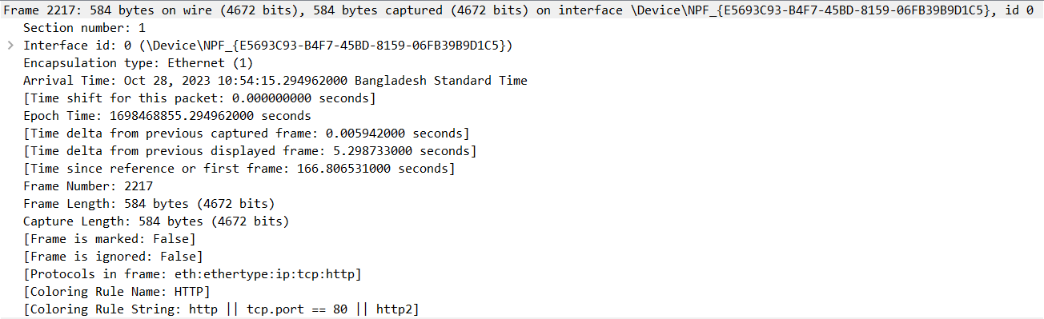

Above in the HTTP request part, the Frame header is included in the Data link layer.

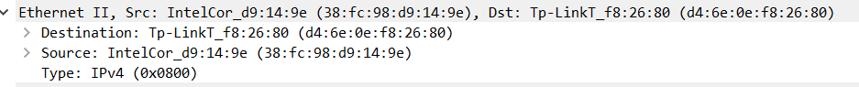

Ethernet II is included in the Data link layer. Above, the mac addresses of source and destination are given.

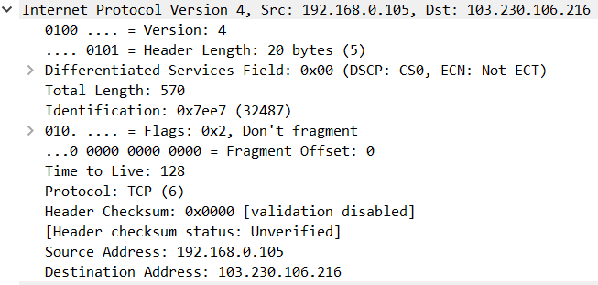

Internet Protocol is basically included in the Network layer. Now, above there are given source IP address and destination IP address where source is my laptop and destination is Teletalk where HTTP request is sent. These addresses are 32 bit addresses. These IP addresses are fixed for that particular source and destination host. TCP protocol is used as this is the most reliable protocol.

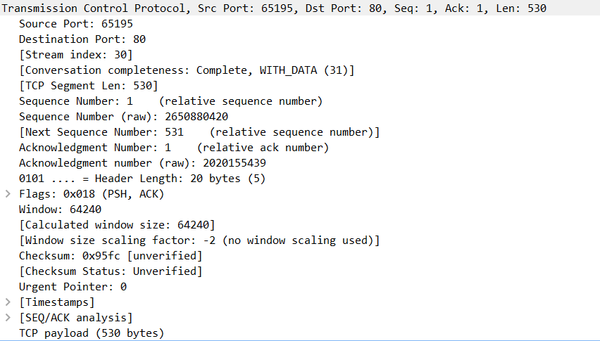

In this transmission layer, there is a given source port and destination port. After TCP connection is established the sequence number is sent to the destination part and from the destination part, sequence number as well as acknowledgement number are given. Through PSH and ACK, push and acknowledgment are happening. Again, window size for the receiver is given to give the request part.

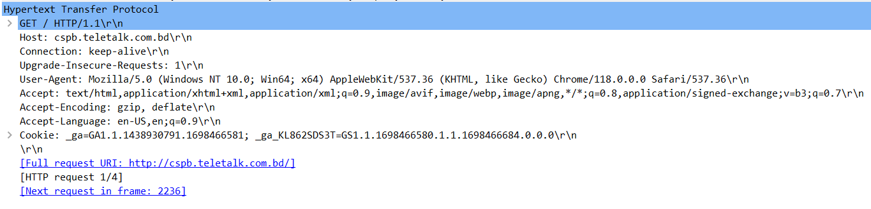

Hypertext Transfer Protocol is included in the application layer. Now, through the ‘GET’ method, an HTTP request is sent. Next, host is what we are searching for, that means cspb.teletalk website I am searching for and so the url is in host. Connection is going on. It is not a secure website and keeps changing frequently.

User-Agent is from where the website is searched. Then, accept is where which type of files like text or html are accepted. Accept encoding and accept language are basically accepting the type of encoding and language. After that, HTTP connection is established and the requests are sent to the destination site.

**HTTP Response:**

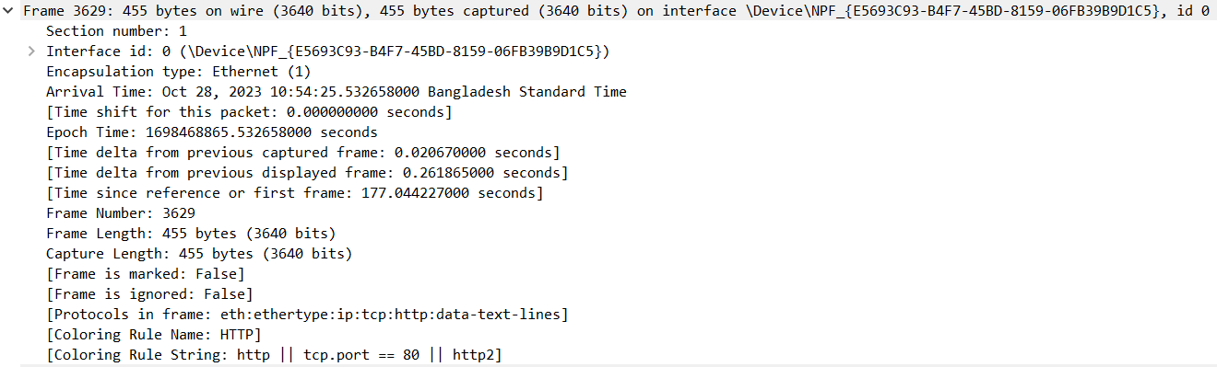

Above in the HTTP response part, the Frame header is included in the Data link layer.



Ethernet II is included in the Data link layer. Above, the mac addresses of source and destination are given.

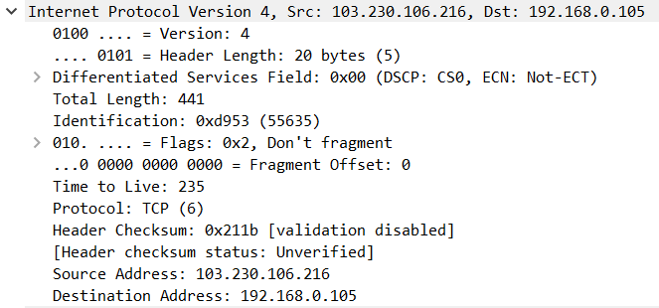

Internet Protocol is basically included in the Network layer. Now, above there are given source IP address and destination IP address where now source is Teletalk and destination is my laptop as HTTP response’s work is happening. These addresses are 32 bit addresses. These IP addresses are fixed for that particular source and destination host. TCP protocol is used as this is the most reliable protocol.

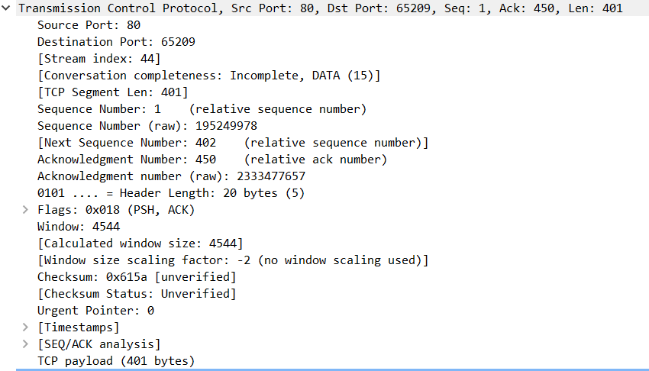

In this transmission layer, there is a given source port and destination port. After TCP connection is established, from the destination part, sequence number as well as acknowledgement number are given. Through PSH and ACK, push and acknowledgment are happening. Again, window size for the receiver is given to give the request part.

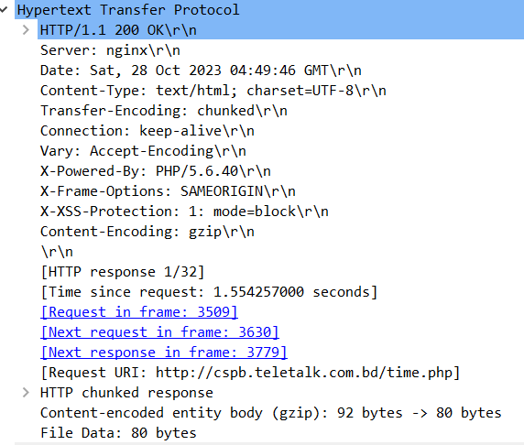

Hypertext Transfer Protocol is included in the application layer. Now, through the first line, an HTTP’s status is written. Next, Header lines are given like date, content-type, connection etc. Then, data is sent which I want to see through HTTP response. After that, other responses come one by one and these responses come in a chunked way. Also, response time and size are given.



The text/html file I am requesting for.